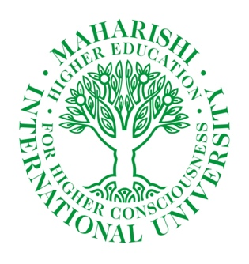


17th Annual Peacemakers Tournament
Maharishi International University

October 24-25, 2025

The 17th annual Peacemakers Invitational Mediation Tournament will be held on Friday and Saturday, October 24-25, 2025.

This three-round tournament will be hosted by Maharishi International University in Fairfield Iowa and will accept registrations beginning September 22nd, 2025

The cost for registration will be $150.00 per three-person team.
We are asking for a maximum of two teams from each school, but if spaces are available, we may be able accept three teams per school.

Please indicate on your registration form if you have the potential to add a team or contribute to bi-team.

We look forward to welcoming you to the Peacemaker Mediation Tournament!

Please send registration forms or an email letting me know you are coming to valexander@miu.edu by October 15th to secure a place.

Payment can be made at the tournament. Checks payable to Maharishi International University

Schedule of Events

Friday, October 24th
12:30 Registration in the Lobby of the Dreier building

1:00 Opening Remarks and Welcome

1:15 - 2:00 Mediation training in Dreier 102

2:15 – 2:45 Judges training in Dreier 102

2:15 Fact distribution for Round 1 Dreier Lobby

2:45 -4:45 First round various locations

Dinner Break (on your own)

6:30 Facts distribution for Round 2 Dreier Lobby

7:00 -9:00 Round Two

Saturday, October 25th
9:15 Facts distribution for Round 3

9:45 – 11:45 Round Three

Noon: Awards lunch in Argiro Student Center, second floor dining area.

https://www.miu.edu/campus-map map of campus

https://www.visitfairfieldiowa.com/ for information on Fairfield.

